CISCO PACKET TRACER

CREATE NETWORK TOPOLOGY
I used five PC, 1 switch and 1 printer
I connected all the pc and the printer with the switch using copper straight-through cables and fast Ethernet ports
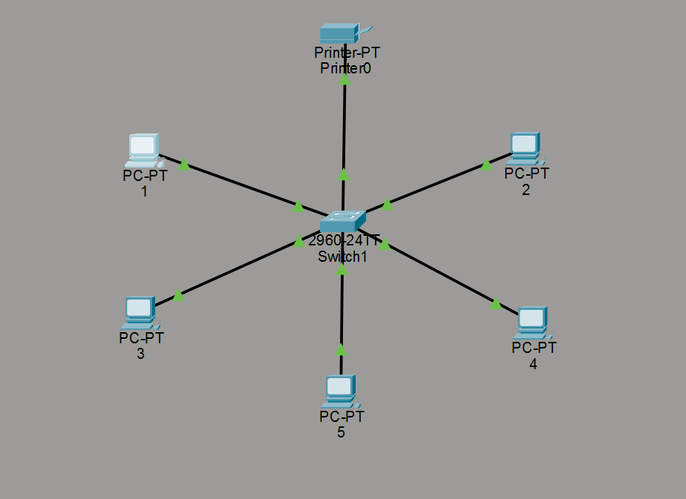

ASSIGN IP ADDRESS
I configured all PCs and the printer in the same subnet
Subnet mask used: 255.255.255.0
The IP ADDRESSES on each pc and printer are as follows:
PC AND PRINTERS |  | IP ADDRESS
PC 1 |  | 192.168.1.2
PC 2 |  | 192.168.1.3
PC 3 |  | 192.168.1.4
PC 4 |  | 192.168.1.5
PC 5 |  | 192.168.1.6
PRINTER |  | 192.168.1.9

The Screen shots are attached for reference:
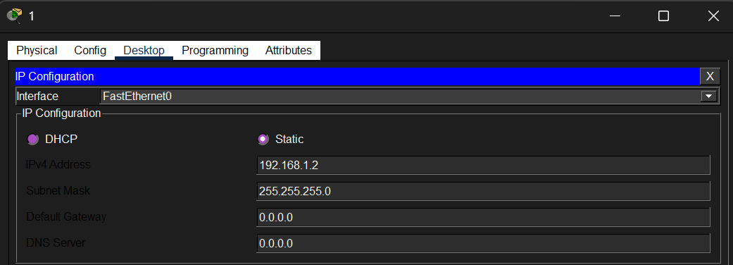
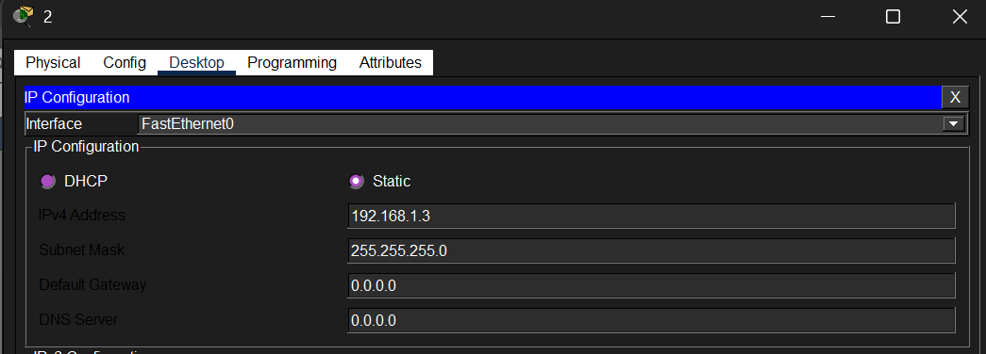
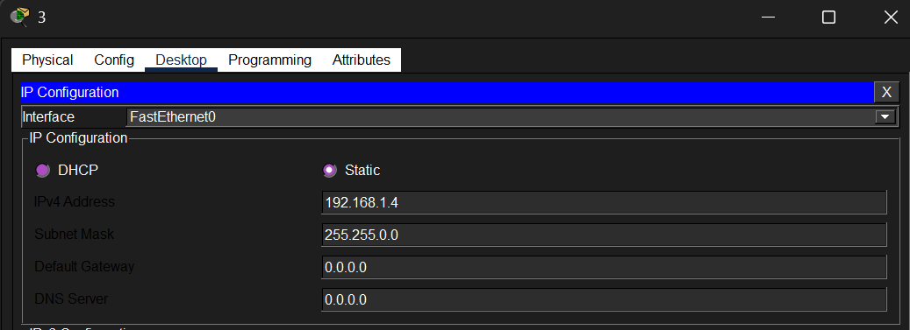
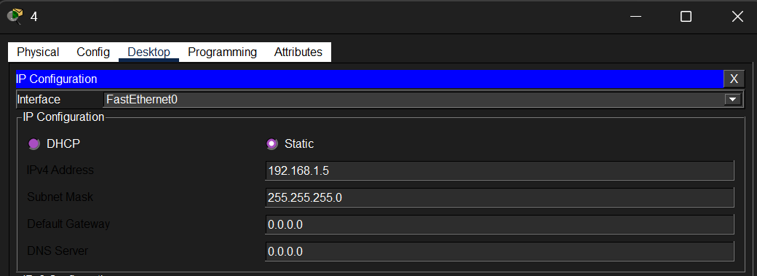
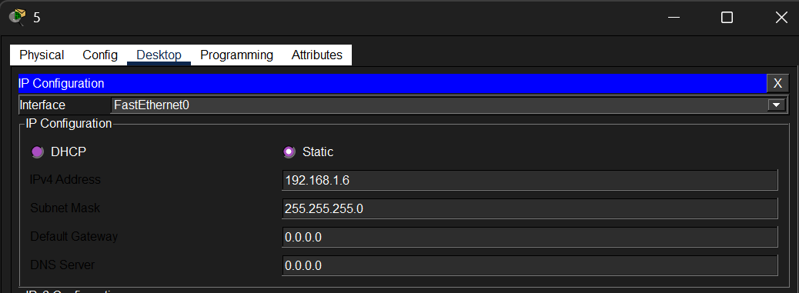
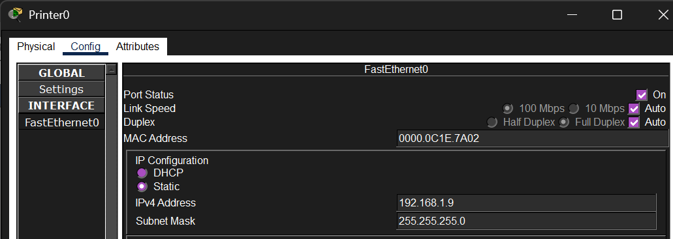

CONFIGURE NETWORK DEVICES
I opened the command prompt in packet tracer and typed ping <IP-address> of each pc in pc 1
All PCs successfully responded to ping requests, confirming:
- Correct IP assignment
- Successful switch connectivity
- Devices are in the same subnet

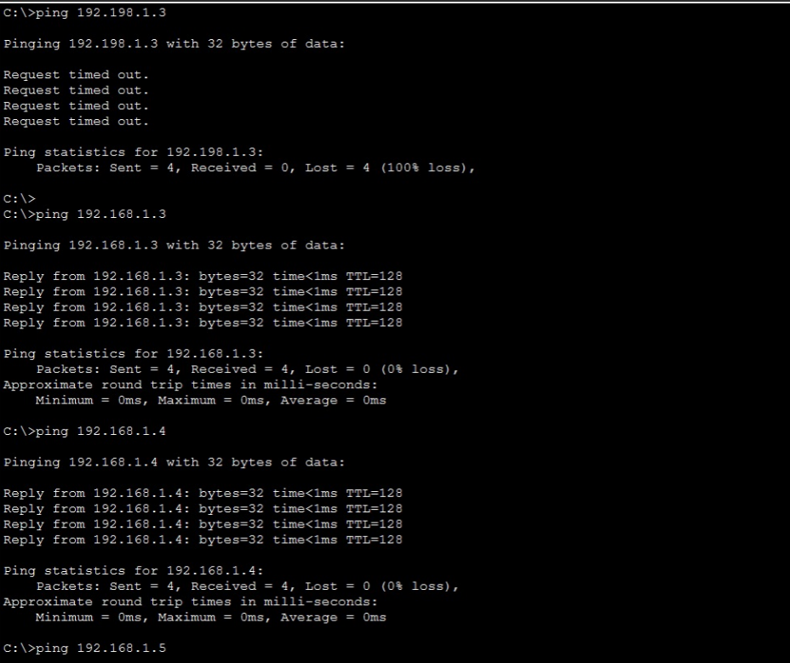

SET UP PRINTER SHARING
Since all the PCs can ping the printer successfully, it can be concluded that the printer is setup

